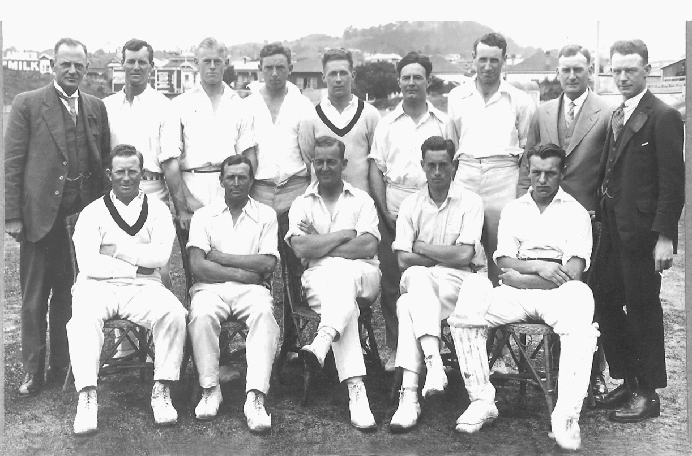

**Canterbury v Auckland 5 January 1924 Eden Park**

Canterbury 110 & 242 Auckland 258 & 97/0. Canterbury lost by 10 wickets

**Back row:** W Simpson, RJ Read, RO Talbot, WHR Cunningham, CJ Olliver, GR Gregory, DJ McBeath, EE Luttrell,

L Guiney

**Front row:** G Young, DN Sandman, WR Patrick (captain), RC Blunt, MK Boon